Cost Function in PyTorch:
Cost Function:
>If use both the total as well as the average Pictorially we are just finding the average area of each square. The sum of the Loss is called the cost. Sometimes we will refer to is the total or average loss.
>The cost function helps in selecting parameters that minimizes the loss value across multiple data points.
>It can be represented as the total or average loss, often denotes as L in PyTorch documentation.
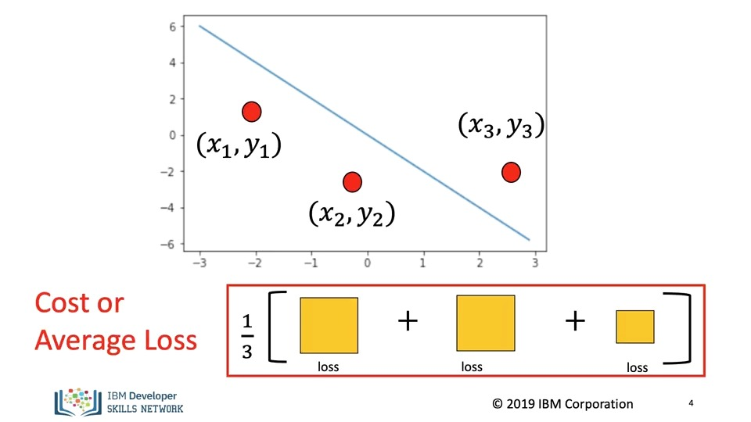
Gradient Descent Process:
>It is performed on the cost function, where the derivative indicates how to update parameters.
>The updates are based on the sign and magnitude of the derivative, which helps the predicted line get closer to the actual data points.
Batch Gradient descent:
>all samples in the training set are referred to as a batch, and using the entire batch for loss calculation is known as batch gradient descent.
>an example, illustrates the process with a batch size of three, where the loss is calculated and the derivate is found for parameter updates.
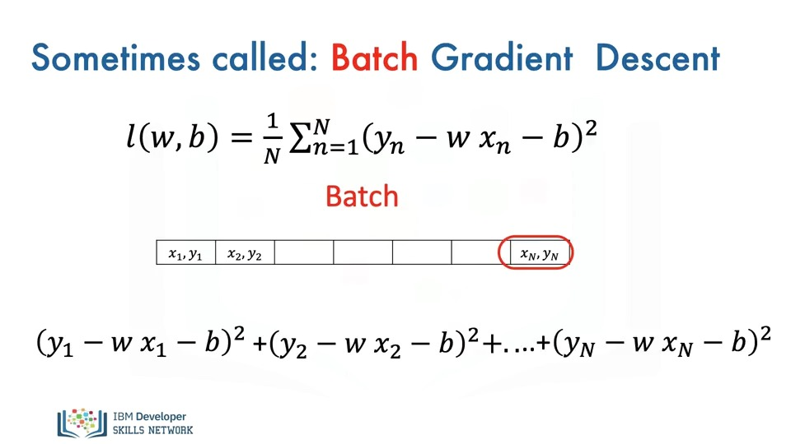
Cost Function in Gradient descent:
>The cost function in gradient descent is a mathematical function that measures the difference between the predicted values produced by a model and the actual values from the dataset. It quantifies how well the model is performing.
Key Points:
Purpose: The cost function helps in determining how to adjust the model's parameters to minimize the error.
Types: Common types of cost functions include:
Mean Squared Error (MSE): Used for regression tasks, it calculates the average of the squares of the errors.

Cross-Entropy Loss: Used for classification tasks, it measures the difference between two probability distributions.
In gradient descent, the goal is to minimize the cost function by iteratively updating the model parameters based on the gradient (derivative) of the cost function. This process helps the model learn and improve its predictions over time.
cost function is not minimized; several issues can arise:
Poor Model Performance: The model will not accurately predict outcomes, leading to high errors in predictions.
Overfitting or Underfitting: Overfitting: The model may fit the training data too closely, capturing noise rather than the underlying pattern.
Underfitting: The model may be too simple to capture the underlying trend in the data, resulting in poor performance on both training and test datasets.
Inefficient Learning: The model may take longer to converge, requiring more iterations and computational resources without achieving satisfactory results.
Inability to Generalize: A model that does not minimize the cost function may fail to generalize well to new, unseen data, leading to poor performance in real-world applications.
The cost function effectively, you can follow these strategies:
Gradient Descent: Use gradient descent to iteratively update model parameters.
The update rule is: [ \theta = \theta - \alpha \cdot \nabla J(\theta) ] where ( \theta ) are the parameters, ( \alpha ) is the learning rate, and ( \nabla J(\theta) ) is the gradient of the cost function.
Learning Rate Tuning:
Choose an appropriate learning rate. A small learning rate may lead to slow convergence, while a large learning rate can cause overshooting. Consider using techniques like learning rate schedules or adaptive learning rates (e.g., Adam optimizer).
Batch Processing: Use mini-batch gradient descent instead of full-batch or stochastic gradient descent. This balances the benefits of both approaches, leading to faster convergence and more stable updates.
Regularization: Apply regularization techniques (like L1 or L2 regularization) to prevent overfitting, which can help in achieving a better minimum of the cost function.
Feature Scaling: Normalize or standardize your input features to ensure that they are on a similar scale. This can help gradient descent converge faster.
Early Stopping: Monitor the performance on a validation set and stop training when performance starts to degrade, preventing overfitting.
Use of Advanced Optimizers:
- Consider using advanced optimization algorithms like Adam, RMSprop, or AdaGrad, which can adaptively adjust the learning rate based on the gradients.
- By implementing these strategies, you can effectively minimize the cost function and improve the performance of your model.

